| Project ID:PNT2022TMID23204 | Real-Time River Water Quality Monitoring and Control System |
| --- | --- |

**IOT BASED Real-Time River Water Quality Monitoring and Control System**

The proposed solution is to monitor the quality of the river water using ph ,temprature sensor , turbidity sensor and to control the pollution of water .

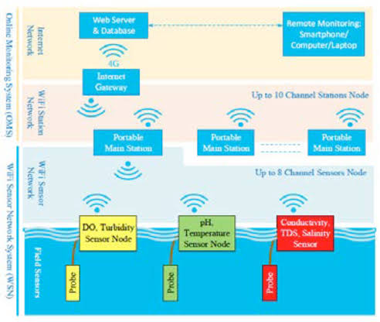

**INTRODUCTION**

**Water is the primary need of all living beings and living without water is impossible. With the advancement of technology and industrialization, environmental pollutions have become a major concern. Water pollution is one of the most serious types of this environmental pollution. Our lives depend on the quality of water that we consume in different ways, from juices which are produced by the industries. Any imbalance in the quality of water would severely affect the humans health and at the same time it would affect the ecological balance among all species. Water quality refers to the chemical, biological, radiological, and biological parameters of the wate**

**Ph and sensor:**

**pH values also process the solubility of elements and compounds making them cyanogenetic. Mathematically pH is**

**referred as, pH = -log [H+].**

**Turbidity sensor**

**Turbidity train sensor is victimised to measure the clarity of element or muddiness utter in the water. The**

**muddiness of the open cut food is ordinarily between 255 NTU. Irrigate is visibly at levels above 80 NTU. The**

**standards for intemperance liquid is 130 NTU to 250 NTU. The turbidity device consists of soft sender and acquirer,**

**the transmitter needs to transmit unsubtle bright, it is said to be turbid. The consequence of turbidity is a reduction in**

**water clarity, aesthetically unpleasant, decreases the rate of photosynthesis, increases water temperature.**

**Temperature sensor**

**Here DS18B20 is old as the temperature device. Usually, its present use to perceive the temperature of the life, if**

**we site the device wrong the conductor electrode and placed into the H2O, it can discover the temperature of H2O**

**also. The normal temperature of the people is (25 -30)°C.**

**LCD display**

**LCD (Liquid Crystal Display) impede is a flat brace electronic exhibit power and finds in a countywide orbit of**

**applications. A 16x2 LCD demo is the really fundamental power and is rattling commonly victimised in varied**

**devices and circuits. These modules are desirable over heptad segments and otherwise multi-segment LEDs.**

**Wi-Fi module**

**Wi-Fi or Wi-Fi is a subject for wireless localized area scheme with devices. Devices that can use Wi-Fi study**

**permit private computers, video-game consoles, smartphones, digital cameras, paper computers, digital frequency**

**players and ultramodern printers. Wi-Fi matched devices can insert to the Cyberspace via a LAN web and wireless**

**make a bushel. Much a reach quantity (or point) has a capableness of around 20 meters (66 feet) indoors and a**

**greater compass outdoors. Wi-Fi subject may be utilised to render the Internet reach to devices that are within the**

**capability of a wireless meshwork that is connected to the Internet.**

**Software design**

**The proposed water quality monitoring system based on WSN can be divided into three parts:**

**• IoT platform**

**• Neural network models in Big Data Analytics and water quality management**

**• Real-time monitoring of water quality by using IoT integrated Big Data Analytics**

**IoT Platform**

**The quality parameters are labeled datasets including desired outputs of specific combination of inputs. The**

**neural network will produce output to classify water quality as dangerous, be careful, and good. The classification**

**layer will run on top of Hadoop cluster [17]. The advantages of using neural network based analytics are like**

**Artificial Neural Networks (ANNs) are good in learning and modeling non -linear relationships, and high volatile**

**data [18]. Though neural networks are prone to over fitting, the neural network model used in water quality**

**monitoring system is not complex enough to cause over fitting problem. Also, there are many countermeasures to**

**avoid over fitting. Also, computation overload is not going to delay the response of system as there are only a few**

**water quality parameters**